INDEXES-WOMEN
HDI - India has been ranked 131st out of 188 countries in the2017 Human Development Index (HDI), as per latest Human Development Report (HDR) 2016 by the United Nations Development Programme (UNDP)
IHDI – The difference between the HDI and IHDI, expressed as a percentage of the HDI, indicates the loss in human development due to inequality. India’s HDI is pegged at 0.624, its value falls 27.2 per cent after being adjusted for inequalities, resulting in a HDI value of 0.455 MPI- India is home to the largest number of MPI poor people in the world.
The Global MPI was updated in June 2017 and now covers 103 countries in total, which are home to76 per cent of the world’s population, or 5.4 billion people. Of this proportion, 26.5 per cent of people (1.45 billion) are identified as multi dimensionally poor. 48% of the poor people live in South Asia, and 36% in Sub-Saharan Africa.
GII by UNDP- It measures gender inequalities in three important aspects of human development—reproductive health, measured by maternal mortality ratio and adolescent birth rates; empowerment, measured by proportion of parliamentary seats occupied by females and proportion of adult females and males aged 25 years and older with at least some secondary education; and economic status, expressed as labour market participation and measured by labour force participation rate of female and male populations. It measures the human development costs of gender inequality. Thus the higher the GII value the more disparities between females and males and the more loss to human development. India is ranked 125 of 159 countries in the Gender Inequality Index
GDI by UNDP - The GDI measures differences between male and female achievements in three basic dimensions of human development:
  - Health measured by female and male life expectancy at birth;
  - education, measured by female and male expected years of schooling for children and female and male mean years of schooling for adults ages 25 and older;
  - Equitable command over economic resources, measured by female and male estimated earned income.
It helps further understanding of the real gender gap in human development achievements and is useful for navigating policies to close the gap. According to GDI 2015, India is ranked 131 with an index of 0.819 and comes under MEDIUM HUMAN DEVELOPMENT. Countries are divided into five groups by absolute deviation from gender parity in HDI values. Group 1 comprises countries with high equality in HDI achievements between women and men (absolute deviation of less than 2.5 percent); Group 2 comprises countries with medium to high equality in HDI achievements between women and men (absolute deviation of 2.5-5 percent); Group 3 comprises countries with medium equality in HDI achievements between women and men (absolute deviation of 5-7.5 percent); Group 4 comprises countries with medium to low equality in HDI achievements between women and men (absolute deviation of 7.5-10 percent); and Group 5 comprises countries with low equality in HDI achievements between women and men (absolute deviation from gender parity of more than 10 percent).
Gender Gap Report by WEF: India slipped 21 places on the World Economic Forum’s Global Gender Gap index to 108, behind neighbours China and Bangladesh, primarily due to less participation of women in the economy and low wages. Measured by four pillars— health, education, the workplace and political representation. Iceland – 1, India – 108, China – 100, Bangladesh – 47
- In India, the work place gender gap is reinforced by extremely low participation of women in the economy (136 out of the total 144 countries covered) and low wages for those who work(136th ranking for estimated earned income), and on average, 66 per cent of women’s work in India is unpaid, compared to12 per cent of men’s. One positive note, India succeeded in fully closing its primary and secondary education enrolment gender gaps for the second year running and for the first time has nearly closed its tertiary education gendergap. However, it continues to rank fourth-lowest in the world on health and survival, remaining the world’s least-improved country on this sub-index over the past decade.

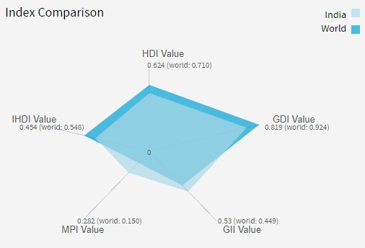
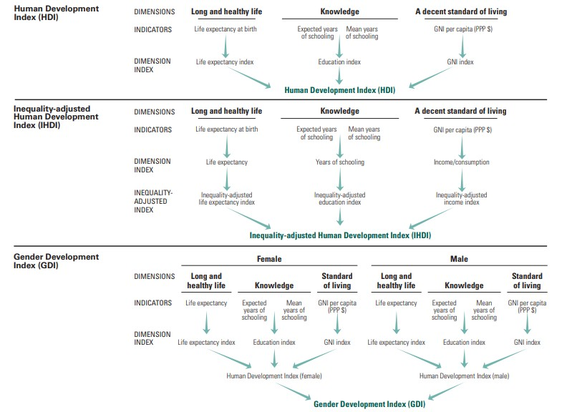
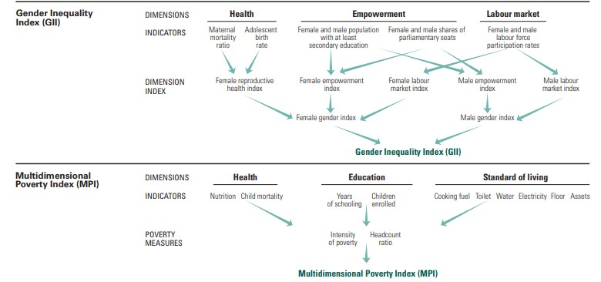

Chronic bias
Indian women don’t enjoy the same rights and privileges as men. Strong preference for the male child has anyway blighted the country’s gender ratio and squeezed resources available for the girl child. As pointed out by the government’s latest economic survey, there are 21 million “unwanted women” and 63 million “missing women” in the country today. Cultural norms still militate against equality. This is manifested in the country’s performance on four key parameters: equal work opportunities, access to services, physical safety, and legal and political representation. India ranks amongst the lowest in a list of 18 from the APAC region on these four criteria. India has a considerable way to travel to match the best performance in the region on female-to-male labour-force participation rate, maternal mortality, financial and digital inclusion, sex ratio at birth, and violence against women.
A higher participation of women in the workforce, raising the number of hours spent by them on the job, and including them in higher-productivity sectors will help spur such economic growth. As women’s contribution to the country’s GDP is currently just 18%, one of the world’s lowest, with only 25% of India’s labour force being female, India’s economy also has a great potential in the Asia-Pacific (APAC) region from improving gender parity.
India ranks 120 among 131 countries in female labor force participation rates and rates of gender-based violence remain unacceptably high. It’s hard to develop in an inclusive and sustainable way when half of the population is not fully participating in the economy. At 17% of GDP, the economic contribution of Indian women is less than half the global average, and compares unfavorably to the 40% in China, for instance. India could boost its growth by 1.5 percentage points to 9 percent per year if around 50% of women could join the work force.
The Economic Times noted three areas such as Agency (relates to women’s ability to make decisions on reproduction, spending on themselves, spending on their households and their own mobility and health), Attitudes (relate to attitudes about violence against women/wives, and the ideal number of daughters preferred relative to the ideal number of sons).
According to the Survey, India's score in 14 out of 17 indicators that relate to the agency, attitude and outcomes have improved over time. In seven of these indicators, there has been such consistent progress that India's performance is better than or at par with other countries.
There has been notable progress in the agency dimension for women, who now have an active decision-making power regarding household purchases and visiting family and relatives. There has also been a decline in physical and sexual violence against women, according to the Survey. Moreover, education levels have also improved. The percentage of educated women has gone up from 59.4 percent in 2005-06 to 72.5 percent in 2015-16.
Out of 17, 10 indicators exist where India has to catch up to other countries. For instance, the employment of women in the workforce has declined from 36 percent employed in 2005-06 to 24 percent in 2015-16. It can be seen that while the number of educated women has gone up, the number of employed women has gone down significantly.
There is a positive downward trend of violence against women – the number of women not facing physical and sexual violence has gone up from 62.6 percent to 70.5 percent between 2005-06 to 2015-16.

